Use Case – Preparing my favorite meal

Contents
Identifier 2
Name 2
Summary 2
Actor 2
Primary 2
Pre-condition(s) 2
Trigger 2
Main Flow 3
AF01 – Alternate flow 1 – Don’t know the ingredients 3
EF01 - Exception flow 1 – Don’t have a specific ingredient 3
Flowchart 4
Version History 5

Identifier

UC001

Name

Prepare my favorite meal

Summary

This use case describes the main steps on preparing a favorite meal. It is only considering the happy path to complete the action, thus, there is no alternative flow. After that, the process is summarized in a simple work flow, aiming to help stakeholders to visualize the process and connect with the written documentation.

Actor

Primary

The Cooker

Pre-condition(s)

- The kitchen must to be clean
- All utensils must to be ready for use

Trigger

This flow starts when the cooker decides to prepare his favorite meal.

Main Flow
- Choose favorite meal
- Prepare ingredient list [Don’t know the ingredients - AF01]
- Separate utensils to use
- Follow recipe instructions [Don’t have a specific ingredient - EF01]
- Finish the meal
- Clean the kitchen

AF01 – Alternate flow 1 – Don’t know the ingredients
- Look for ingredient list in the internet
- Print out the list
- The flow resumes at step 3 of main flow

EF01 - Exception flow 1 – Don’t have a specific ingredient
- Put back utensils
- Clean the kitchen
- Go eat out

Flowchart
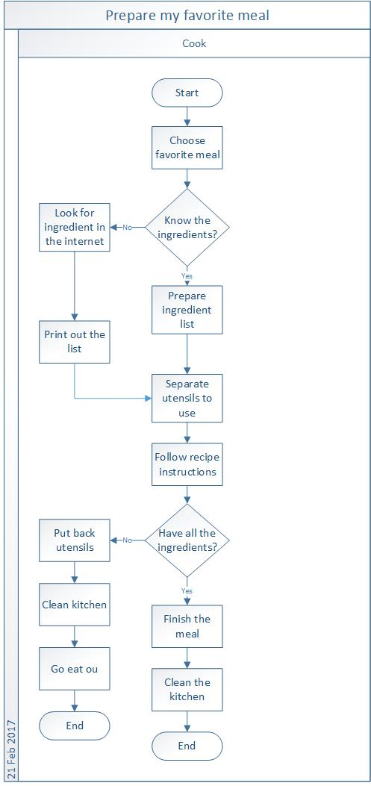

Version History

Version | Date | Status | Description | Author
01 | 21 Feb 2017 | Draft | Creation of the user case documentation | Danilo
02 | 21 Apr 2017 | Draft | Updated the summary | Danilo

